- We expect the Bank of England's Monetary Policy Committee to cut Bank Rate by 25bps at next week's meeting. Cutting at alternate meetings has become the norm, supported even by the more hawkish MPC members, and loosening policy in May would be in keeping with this. We suspect some members may vote for a larger cut, most likely Swati Dhingra and possibly one or two others.
- May's meeting is an opportunity for the committee to explain how recent tariff developments have shaped its outlook. We think the MPC will likely downgrade both its near-term growth and inflation forecasts.
- Early signs suggest the committee may be open to adopting a more proactive approach to loosening policy at subsequent meetings. How the MPC balances the demand shock from US tariff announcements against its existing concerns about weak supply will be key.
The Bank of England's Monetary Policy Committee has settled into a pattern of lowering Bank Rate at alternate meetings since the rate-cutting cycle kicked off last August. Following a pause at the last meeting in March, we regard a 25bps cut to 4.25% at May's meeting as virtually certain, though some committee members may vote for a larger cut, most likely Swati Dhingra and possibly one or two others. Financial markets are fully pricing in a 25bps reduction next week.
But beyond May's interest rate decision, the more important question is how US tariff announcements are influencing the MPC's thinking. Recent meeting minutes have emphasised that the key debate among committee members is around whether the weakness in domestic activity primarily reflects subdued demand or constrained supply. With US trade policy presenting a new demand shock, there have been early signs that the MPC is willing to adopt a more proactive approach to loosening policy. But May's meeting minutes and press conference will be the first opportunity for the MPC to clearly set out how recent developments have shaped its outlook and what committee members will be focusing on ahead of future interest rate decisions.
Chart 1: Higher US tariffs point to weaker growth and inflation over the next couple of years
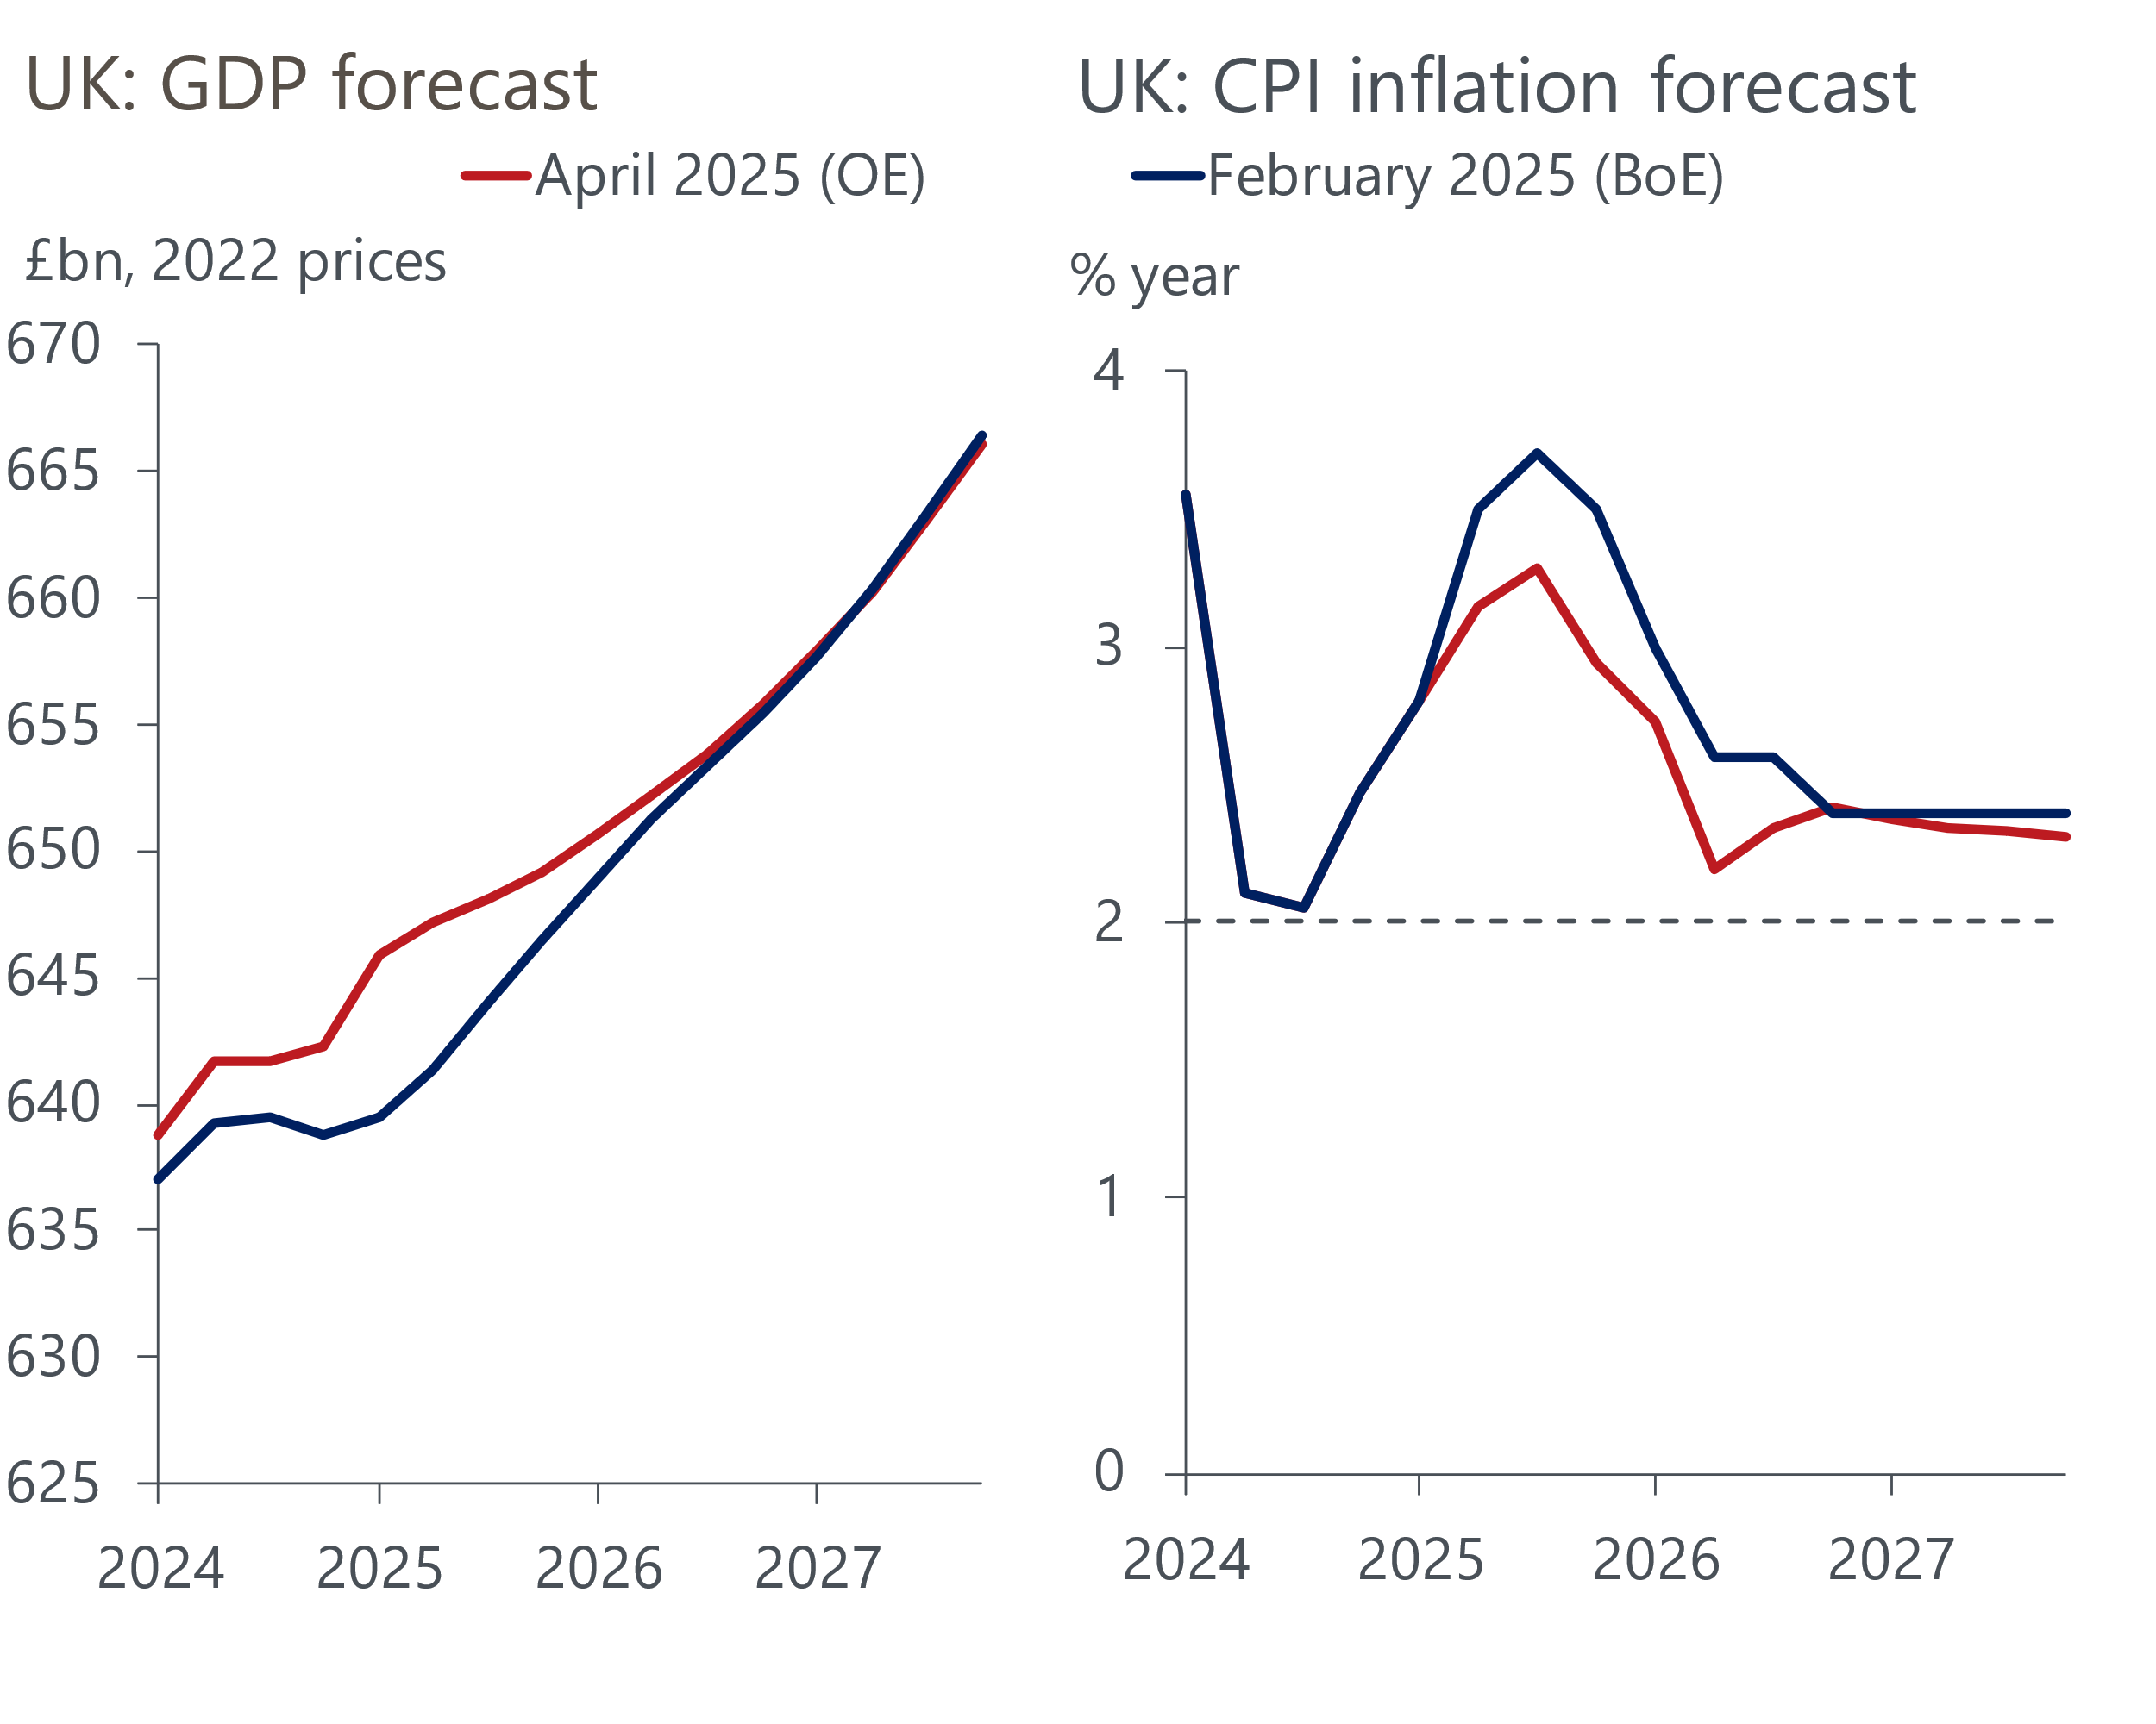
Sources: Oxford Economics, Haver Analytics, Bank of England

Tariff increases are largely a negative demand shock for the UK
The near-term UK growth outlook already looked challenging – recent US tariff announcements have added to the headwinds. Higher US tariffs will directly drag on roughly 6% of total UK exports. Tariffs will also indirectly weaken demand for UK exports by weighing on US growth and demand from the rest of the world. Our past research has also shown that a prolonged period of trade policy uncertainty will harm UK business investment, which is already under pressure from weak profitability and the squeeze from higher labour costs. As a result, we now expect much weaker UK GDP growth over the next few years (Chart 1).
Financial markets have become markedly more dovish over recent months, largely based on the belief that much weaker growth prospects will allow the MPC to cut Bank Rate more aggressively to shore up demand without compromising its inflation mandate. As a result, the MPC's new forecast will be based on market interest rate expectations that are around 45bps lower by the end of this year than when the MPC presented its previous forecast in February (Chart 2).
Chart 2: Markets have become much more dovish since the MPC's last forecast in February
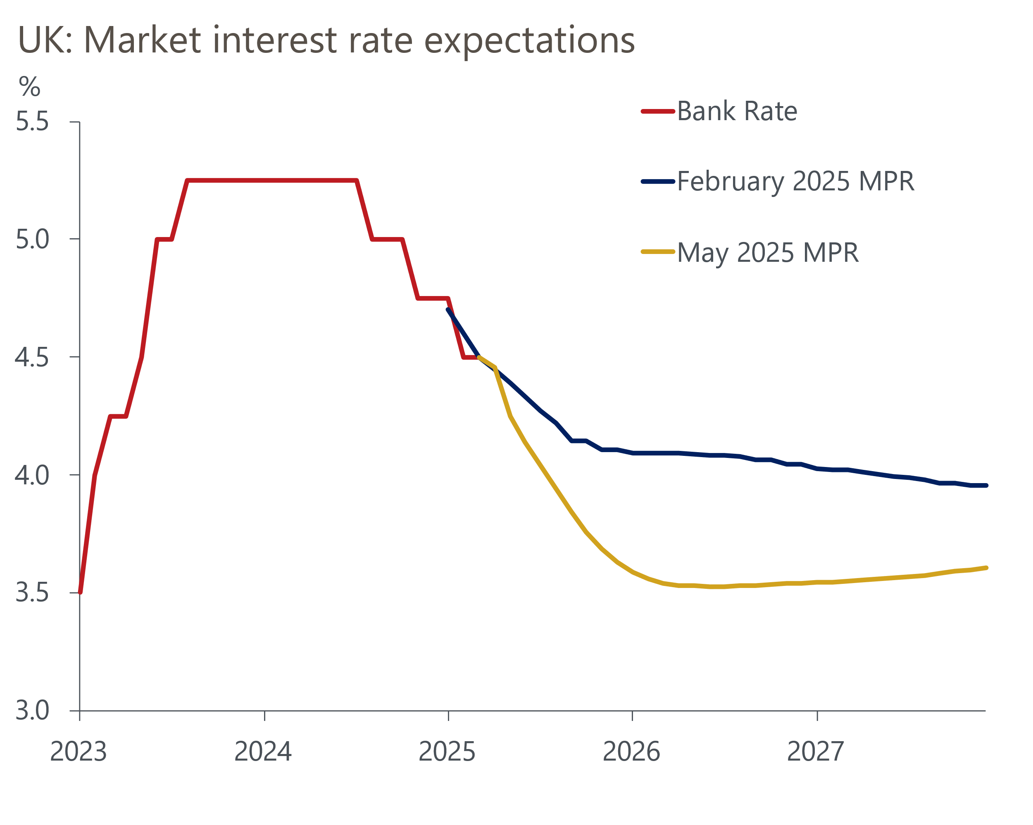
Source: Haver Analytics
Favourable historical revisions and a much stronger-than-expected Q1 mean the MPC's new GDP projection will start from a higher level. Meanwhile, the lower conditioning path for Bank Rate should mitigate some of the hit to the MPC's growth forecast from weaker domestic demand, particularly in the medium term.
The market response to recent tariff announcements also points to slightly lower inflation in the near-term. The dollar has weakened against most currencies, including sterling, which will lower the prices of dollar-denominated imports. Against the backdrop of weaker global growth, there has also been a repricing in commodity markets. Oil and to a lesser extent European gas and electricity futures prices have fallen in recent weeks (Chart 3). This will pull down near-term UK petrol and domestic energy prices, and put some downward pressure on the MPC's headline inflation forecast in 2025 and 2026.
Chart 3: The MPC's new forecasts will assume a weaker dollar and lower oil and gas prices
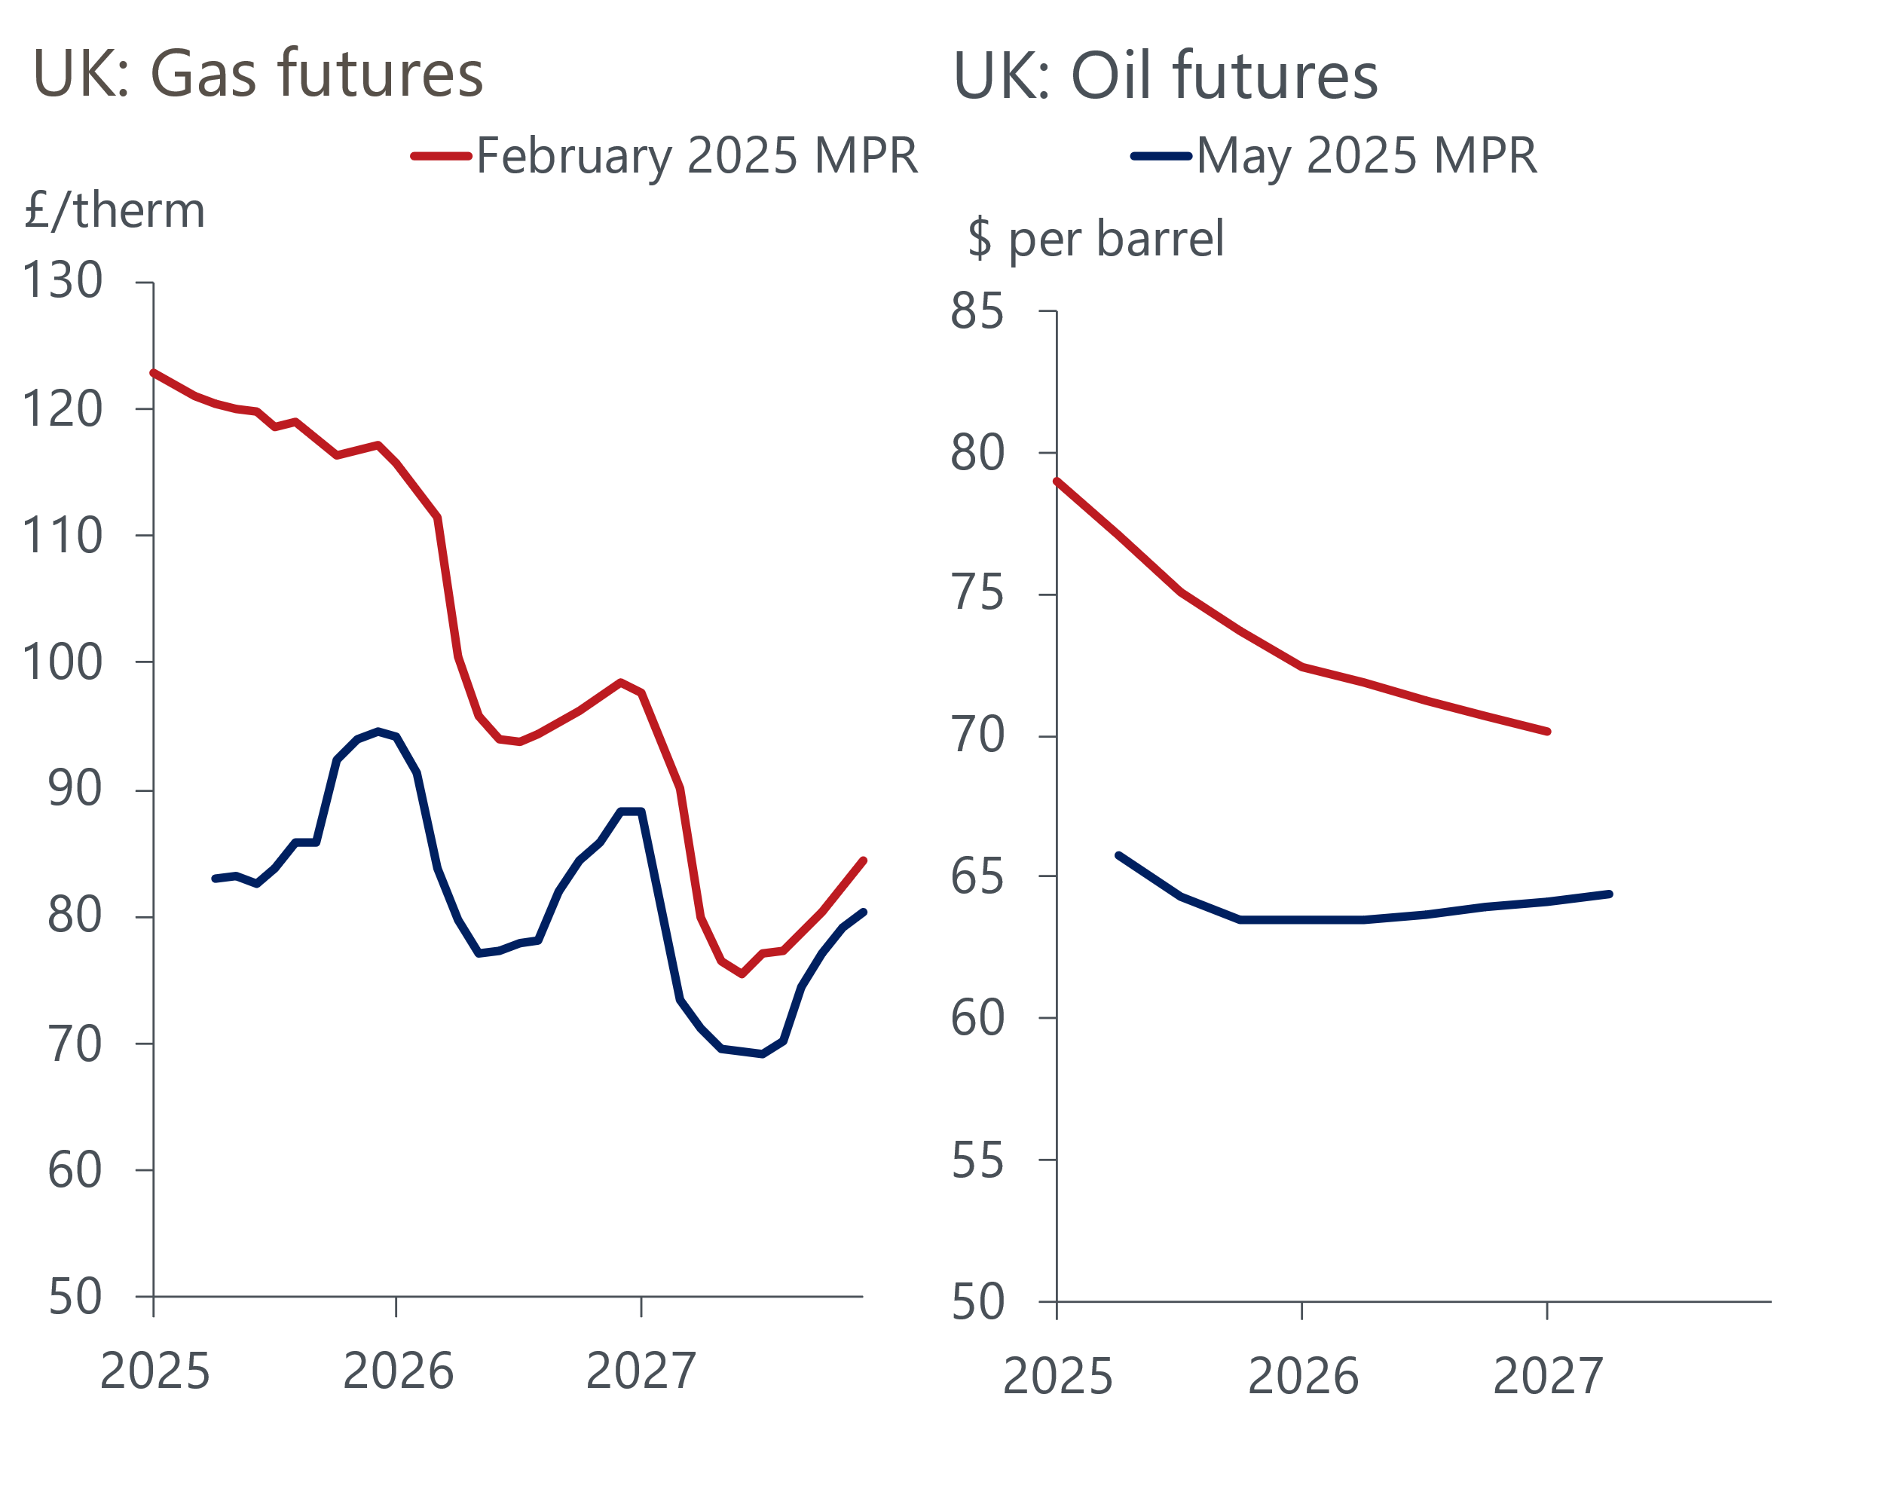
Source: Haver Analytics

But concerns about supply weakness will linger
We've established that the tariff announcements are largely a negative demand shock. However, the exact scale of the shock is uncertain, as is how the MPC will weigh this up against existing worries over supply. The MPC's forecast of this area will be more judgemental than mechanistic, but there have been few recent signs of progress in the data on factors that could quell the committee's concerns about supply. The MPC's favoured measure of underlying inflationary pressure, which excludes indexed and volatile components, rent, and foreign holidays from services inflation, has stopped falling in recent months (Chart 4). Private sector regular pay growth – the MPC's preferred measure of pay growth – has been slightly weaker than the MPC expected in recent months, but still remains well above a pace that would be consistent with sustainably meeting the committee's 2% inflation target in the medium term.
Chart 4: The MPC's favoured measures of underlying inflationary pressures show little progress
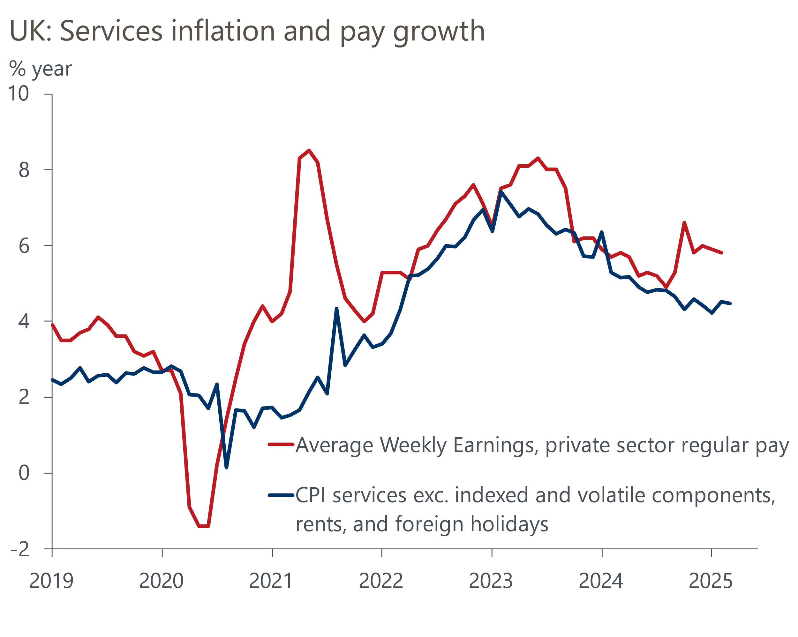
Source: Oxford Economics calculations using data from Haver Analytics

May cut is a done deal and the MPC could signal a less cautious approach ahead
Prior to the increase in US tariffs, some committee members voiced concerns that weak potential output may mean that there's little spare capacity in the economy, which risks the persistence in wage- and price-setting becoming more structural. We recently published a Research Briefing outlining why we think some of these concerns may be misplaced. There are some early signs that a majority of committee members are coming round to our view, particularly in light of recent US tariff announcements, and are open to taking a more proactive approach to cutting.
Over the past week, BoE Governor Andrew Bailey, who is a reliable bellwether of MPC sentiment, has placed particular emphasis on the risk to growth from higher tariffs (Table 1 shows our analysis of recent comments by MPC members). Meanwhile, other committee members who have previously been more concerned about the weakness of supply, such as Megan Greene, have suggested that the balance of risks has tilted towards the disinflationary side.
Table 1: Key comments by MPC members since the March meeting
Speaker and link | Date | Key takeaway
Greene | April 25 | In a discussion with the Atlantic Council think tank, Greene reiterated her long-held concerns about weak productivity and supply constraints on the economy. However, she also noted that recent tariff announcements have shifted her outlook to a degree, saying "In my mind, the risk space has changed a little bit. So I think the risk is now on the disinflationary side. So I think that tariffs on the UK would, on net, be more disinflationary than they are inflationary".
Bailey | April 23 | Speaking at an Institute of International Finance event in Washington, the Governor placed particular emphasis on the potential hit to growth, saying that the committee "have to take very seriously the risk to growth". In a later interview, Bailey doubled down on this message, remarking that "we are certainly quite focused on the growth shock".
Breeden | April 10 | During an online panel, Breeden said that "if nothing else, the chilling effect of trade policy uncertainty on firms and consumers is clear". She added "I would expect tariffs to lower economic activity as barriers to trade inherently weigh on global demand". Breeden was less willing to offer a steer on the implications for inflation, saying that "the answer on inflation is not clear-cut", though she did single out the exchange rate as a "key determinant" to her view.
Lombardelli | April 8 | Similar to Breeden, Lombardelli has been more willing to comment on the negative growth implications of US tariffs but not on the impact on inflation. Speaking during a panel discussion at a Resolution Foundation event, Lombardelli said "we know the tariffs are likely to depress activity overall, the direction is relatively clear. On inflation, it depends a lot more "on the circumstances of actually how other countries respond".
Source: Oxford Economics
Key to the MPC's communications will be a recasting of the committee's inflation scenarios. In the minutes from the March meeting, the committee signalled that the scenarios will be replaced in May and will build on recent discussions around the balance of supply and demand. We suspect the MPC will incorporate a range of US trade policy impacts as part of the narratives. A more dovish scenario is likely to lean on the view that the negative shock to demand shock will dominate and result in inflation dissipating quickly. Meanwhile, a more hawkish scenario may suggest that trade frictions could exacerbate structural factors that are weighing on potential output, which risks greater persistence in wage- and price-setting.
How the MPC positions its central forecast relative to the scenarios will indicate how it views the balance of risks. Similarly, where the MPC expects inflation to settle in the final year of its forecast based on market interest rate expectations and the skew of this forecast, will give a good guide to how it views current market pricing. We suspect the MPC may also drop its reference to undertaking a "gradual" approach to loosening policy from the minutes (Chart 5). This would reflect the committee's openness to adopting a faster pace of cuts should the downward pressure on growth and inflation from US tariffs prove sufficiently large.

Chart 5: We think the MPC may drop its reference to gradualism in the minutes
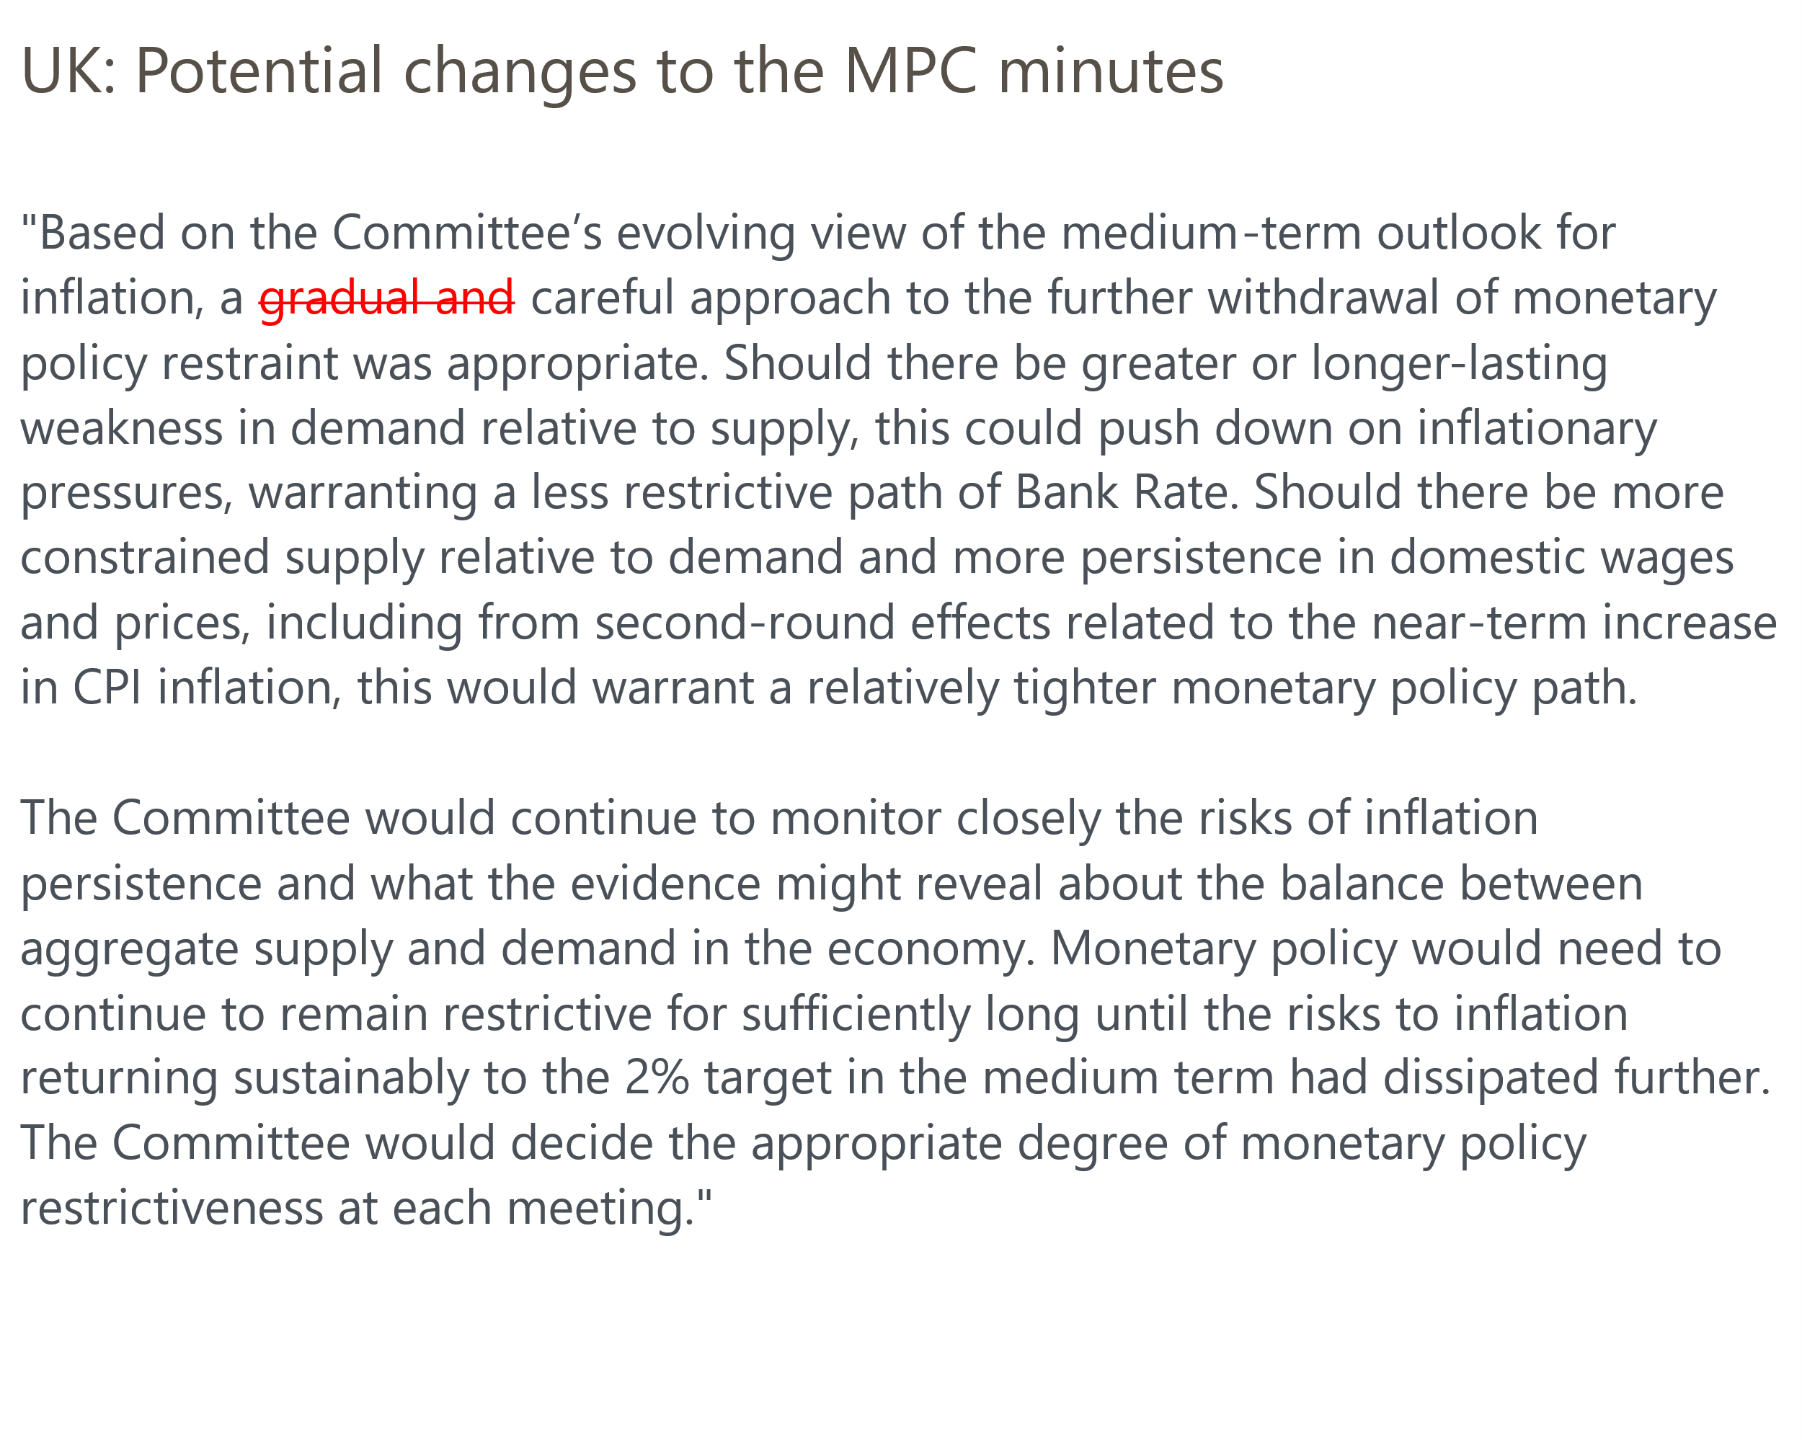
Source: Oxford Economics

